【What day is today?】
Name:
各位同學，你知道星期日、星期一、星期二、星期三、星期四、星期五以及星期六的英文怎麼說嗎？你知道如何用英文問「今天是星期幾」嗎？讓我們一起來看看下面的對話。

1. ：What day is today? ：Today is Sunday.

2. ：What day is today? ：It is Monday.

3. ：What day is today? ：It’s Tuesday.

4. ：What day is today? ：Today is Wednesday.

5. ：What day is today? ：It is Thursday.

6. ：What day is today? ：It’s Friday.

7. ：What day is today? ：It’s Saturday.

※從前面的對話我們可以知道……
星期一的英文是 ，星期二的英文是 ，
星期三的英文是 ，星期四的英文是 ，
星期五的英文是 ，星期六的英文是 ，
星期日的英文是 ，今天的英文是 。
What day is today? 的意思是


- 念一念
Sunday, Monday, Tuesday,
Wednesday, Thursday,
Friday, Saturday.

- 你知道嗎?一星期七天每個都有簡稱，就是全名的前三個字母，例如星期日全名為Sunday，簡稱取其前三個字母Sun.記得要加縮寫符號（.）喔！現在請你用簡稱寫寫看。
英文 | 縮寫 | 中文 |  | 英文 | 縮寫 | 中文
Sunday | Sun. | 星期日 |  | Thursday
Monday |  |  |  | Friday
Tuesday |  |  |  | Saturday
Wednesday
另外Today is Sunday. 可以說 It is Sunday. 也可以說 It’s Sunday. 所以……
- Today is Monday.
可以說 is Monday.
也可以說 Monday.
- Today is Tuesday.
可以說 Tuesday.
也可以說 Tuesday.
3.Today is Wednesday.
可以說 Wednesday.
也可以說 Wednesday.
- Today is Thursday.
可以說 .
也可以說 .
- It is Friday.
可以說 Friday.
也可以說 Friday.
- It’s Saturday.
可以說 .
也可以說 .
※問答練習
請看圖回答問題
例題一：用Today is…的句型回答
1 | 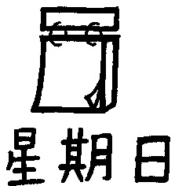 | ：What day is today?  ：Today is Sunday.
2 | 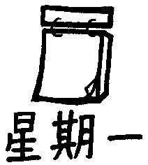 | ：What day is today?  ：Today .
3 | 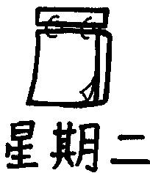 | ：What day is today?  ：Today .
4 | 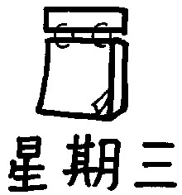 | ：What day is today?  ：Today .
5 | 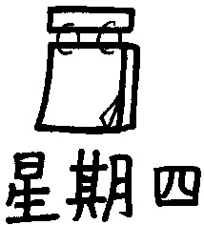 | ：What day is today?  ： .
6 | 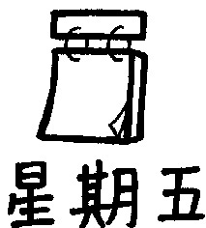 | ：What day is today?  ： .
7 | 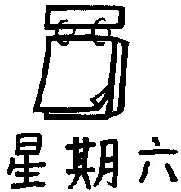 | ：What day is today?  ： .
例題二：用It is…的句型回答
1 |  | ：What day is today?  ：It is Monday.
2 |  | ：What day is today?  ：It .
3 |  | ：What day is today?  ：It .
4 |  | ：What day is today?  ：It .
5 |  | ：What day is today?  ： .
6 |  | ：What day is today?  ： .
7 |  | ：What day is today?  ： .

例題三：用It’s…的句型回答
1 |  | ：What day is today?  ：It’s Friday.
2 |  | ：What day is today?  ：It’s .
3 |  | ：What day is today?  ：It’s .
4 |  | ：What day is today?  ：It’s .
5 |  | ：What day is today?  ： .
6 |  | ：What day is today?  ： .
7 |  | ：What day is today?  ： .

- 寫完後，和同學互相練習問答。
- 縮寫練習：請將正確答案填入空格中
英文 | 縮寫 | 中文 |  | 英文 | 縮寫 | 中文
Sunday | Sun. | 星期日 |  | Thursday
Monday |  |  |  | Friday
Tuesday |  |  |  | Saturday
Wednesday

英文 | 縮寫 | 中文 |  | 英文 | 縮寫 | 中文
 |  | 星期日 |  |  |  | 星期四
 |  | 星期一 |  |  |  | 星期五
 |  | 星期二 |  |  |  | 星期六
 |  | 星期三

英文 | 縮寫 | 中文 |  | 英文 | 縮寫 | 中文
 | Sun. | 星期日 |  |  | Thu.
 | Mon. |  |  |  | Fri.
 | Tue. |  |  |  | Sat.
 | Wed.

